**Auto Highlighter User Guide**

1. Extract/Unzip the files to any location you prefer (Script might not work if the files aren’t extracted or unzipped)
2. After extracting, you should see the following files in the folder (Sample files are provided. They may be deleted if no longer needed.):   
   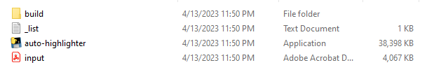
3. To use the script, the PDF you want to work on should always be within the same folder as the script.
4. Open the “_list.txt” file to modify the list of words you want to highlight in the output.
5. Always rename the file you want to work on to “input”.
6. Run the script “auto-highlighter”.
7. If you see the prompt below, just click “More info”, then “Run anyway”.  
   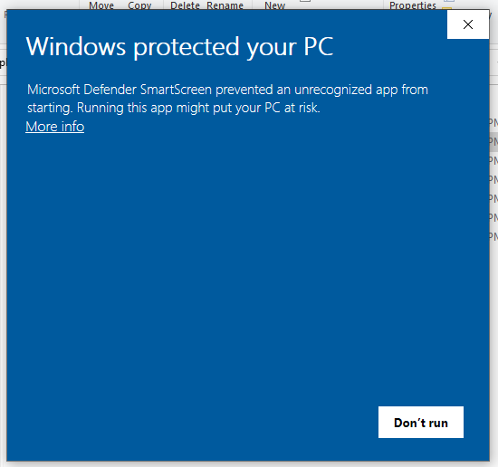
8. It should process the PDF file. Please do not close the terminal and leave it in the background. It will auto-close once complete.
9. It should return the output as “output.pdf” in the same folder.

For any issues with this script, please contact me: Aldrin Renz Cruz (aldrinrenzcruz@proton.me).